**Full Stack Development with MERN**

**Database Design and Development Report**

| Date | 18/07/2024 |
| --- | --- |
| Team ID | SWTID1719999205 |
| Project Name | Darshan Ease |
| Maximum Marks |  |

**Project Title**: Darshan Ease

**Date**: 18/07/24

**Prepared by**: [Sashidhar Reddy, Adhvik Sai, A Bharath, Yuva Sai Rithvik]

**Objective**

The objective of this report is to outline the database design and implementation details for the Darshan Ease project, including schema design and database management system (DBMS) integration.

**Technologies Used**

* **Database Management System (DBMS):** MongoDB
* **Object-Document Mapper (ODM):** Mongoose

**Design the Database Schema**

The database schema is designed to accommodate the following entities and relationships:

**1. Users**

- Attributes: [Name, Password, Email, Phone Number]

**2. Admins**

- Attributes: [Name, Password, Email, Phone Number]

**3. Temple Representative**

- Attributes: [Name, Password, Email, Phone Number, Temple Name, Temple Address]

**4. Services**

- Attributes: [Service, Time, Price, Description]

**5. Donations**

- Attributes: [Name, Amount]

**6. Announcements**

- Attributes: [Name, Content]

**7. Contacts**

- Attributes: [Email, Mobile, Timings]

**Implement the Database using MongoDB**

The MongoDB database is implemented with the following collections and structures:

Database Name: Darshan Ease

1. Collection: users

- Schema:

{

Name: string,

Password: string,

Email: string,

Phone Number: string

}

2. Collection: admins

- Schema:

{

Name: string,

Password: string,

Email: string,

Phone Number: string

}

3. Collection: users

- Schema:

{

Name: string,

Password: string,

Email: string,

Phone Number: string,

Temple Name: string,

Temple Address: string

}

4. Collection: Services

{

Service: string,

Time: string,

Price: number,

Description: string

}

5. Collection: Donations

{

Name: string,

Amount: number

}

6. Collection: Announcement

{

Name: string,

Content: string

}

7. Collection: Contacts

{

Email: string,

Mobile: string,

Timings: string

}

**Integration with Backend**

* Database connection: Give Screenshot of Database connection done using Mongoose

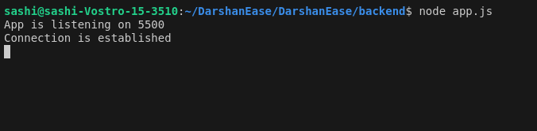

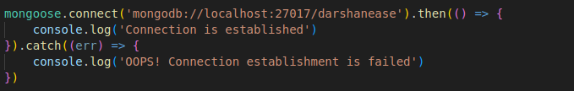

* The backend APIs interact with MongoDB using Mongoose ODM Key interactions include:
  + User Management: CRUD operations for users.
  + Services management: Manages the services.
  + Announcements Management: manages the announcements
  + Donations management: Manages the donations.